**********************************************************************************

**Exercise 3:**

**Aim: Adding and Altering Business Rule, Naming Constraints, Dropping Constraints and Testing Simple Queries**

**Author: 24251115**

**Date: 18/12/2024**

**********************************************************************************

1. Create the following relations
2. 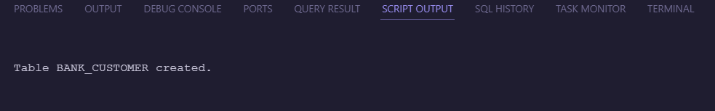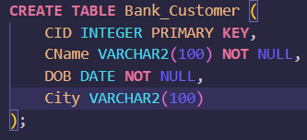Bank_Customer(CID Integer, Cname NN, DOB NN, City NN City Name in Capital Letters)
3. 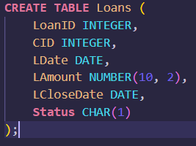Loans(LoanID Integer , CID Integer , LDate Date, LAmount Number(10,2), LCloseDate Date, Status Char(1))



1. Add the following constraints
   1. Add constraint to Loans to make LCloseDate > Ldate
   2. Make CName to accept in Capital Letters
   3. Add Constraint to Loans make Status to accept only the values ‘A’, ‘C’, ‘N’.
2. Insert few records to both the table (3 Records to Bank_Customer and 9 Records to Loans)

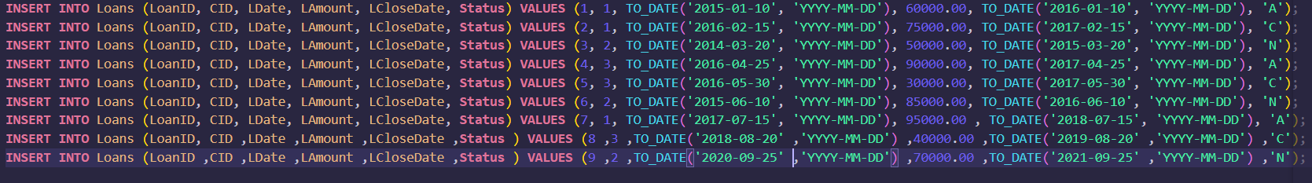

1. Add the following Constraints with **the constraint Names**
   1. Add primary Key to BankCustomer (CID) and Loans (LoanID)



* 1. Add Foreign Key to Loans(CID)
  2. Drop the Foreign Key and Recreate the same with ON DELETE CASCADE/SET NULL option
  3. Drop the Business Rule constraints (LCloseDate and CName)

1. Do the following queries
   1. 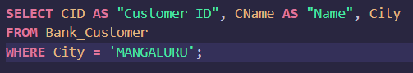Display all the Customer ID, Name, City for those customers whose city=’Mangaluru’



* 1. 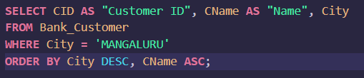Display all the Customer ID, Name, City for those customers whose city=’Mangaluru’ in the Descending Order of City and Ascending order of Customer name



* 1. 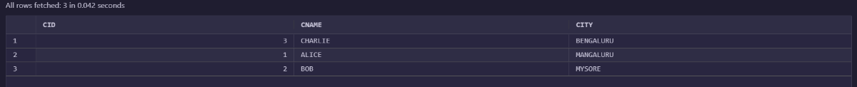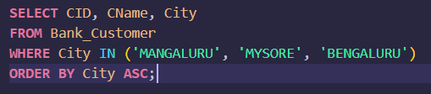Display all the Customer ID, Name, City for those customers whose city is either ’Mangaluru’, ‘Mysore’ or ‘Bengaluru’ in the ascending order of City
  2. 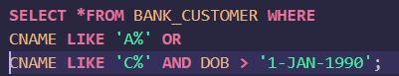Display all the Name, City for those customers whose name begins with ‘A’ or ‘C’ and DOB > 1st Jan 1990
  3. 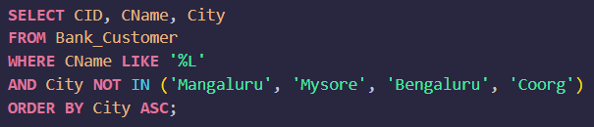Display all the Customer ID, Name, City for those customers whose Name ends with letter ‘L’ and city is NOT ’Mangaluru’, ‘Mysore’ or ‘Bengaluru’ or ‘Coorg’ in the ascending order of City



* 1. 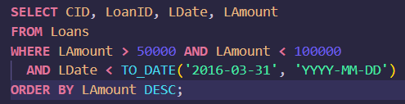Display all the Customer ID, LoanID, LDate, Lamount for those customers whose Loan Amount is >50,000 and less than 1,00,000 and Loan Date is before 31st March 2016 in the Descending order of Lamount

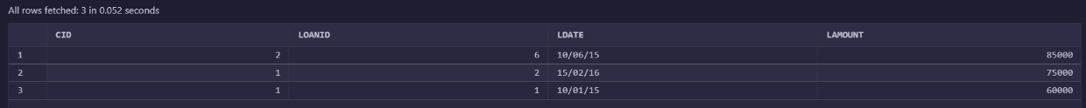

**********************************************************************************

**Exercise 4:**

**Aim: i) Naming all the constraints during creation of table**

**ii) Testing aggregate functions**

**Author: 24251115**

**Date: 18/12/2024**

**********************************************************************************

Create a table named Student_Bio(Regno Int Primary Key, Sname Varchar(20) Not Null, DOB date Not Null, City varchar(15), Category varchar(3) should accept only ‘GEN’,’OBC’,’SC’,’ST’, Total_Marks number(3) Total_Marks >0)

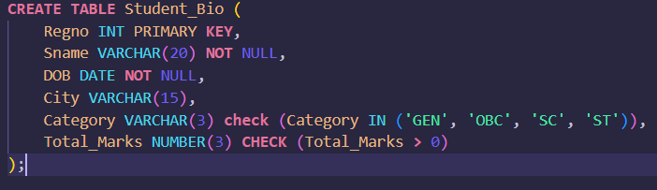



**Note : Add Constraints while creating tables and also name the constraints**

1. 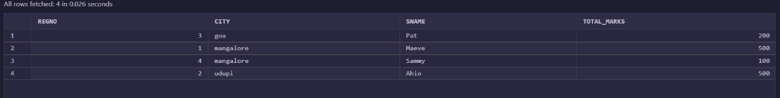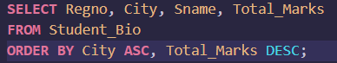Display all the Regno, City, Sname,Total Marks in the Ascending order of City descending order of Total_Marks
2. 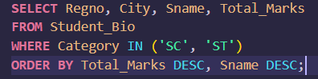Display all the Regno, City, Sname,TotalMarks for Category =”SC” or “ST” in the Descending order of Marks and descending order of SName
3. 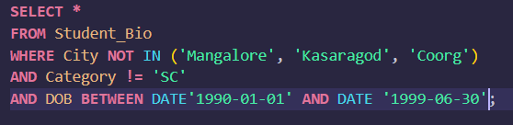Display all students who do not belong to city ‘Mangalore’, ‘Kasaragod’ and ‘Coorg’ and whose category is NOT ‘SC’ and DOB is in between 1st Jan 1990 and Jun 30th 1999
4. 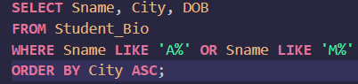Display all the student name, city name, dob whose name begins with letter ‘A’ or letter ‘M’ in the ascending order of city
5. 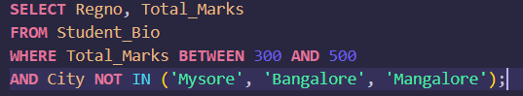Display all the Regno and Marks for those whose marks are in between 300 and 500 and who do not belong to City ‘Mysore’, ‘Bangalore’, ‘Mangalore’



1. 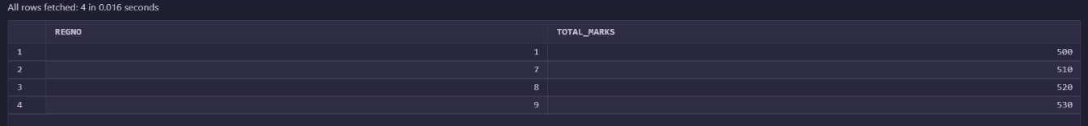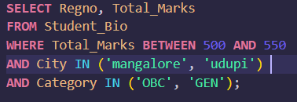Display all the Regno and Marks for those whose marks are in between 500 and 550 and City is either ‘Mangalore’ or ‘Udupi’ and Category is either ‘OBC’ or ‘GEN’
2. 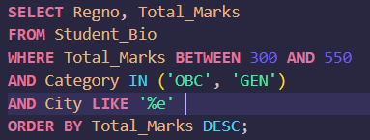Display all the Regno and Marks for those whose marks are in between 300 and 550 and Category is either ‘OBC’ or ‘GEN’ and City name ends with letter ‘e’ in the descending order of Total_marks

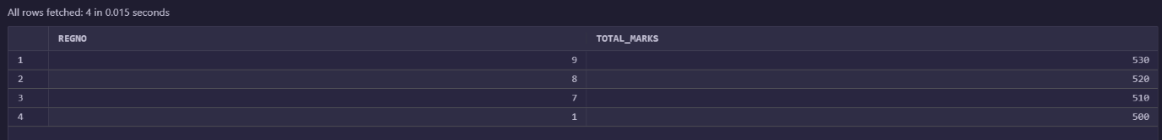

Consider the following Tables and the execute the given queries

1. 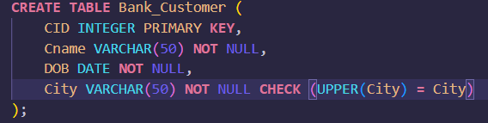Bank_Customer(CID Integer, Cname NN, DOB NN, City NN City Name in Capital Letters)
2. 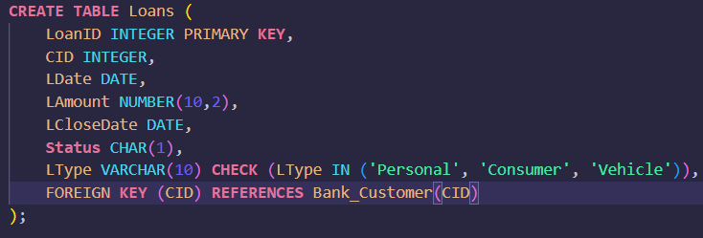Loans(LoanID Integer , CID Integer , LDate Date, LAmount Number(10,2), LCloseDate Date, Status Char(1), Ltype varChar(10) ‘Personal’, ‘Consumer’,’Vehicle’)
3. Count the total records in Bank_customers whose city is not null
4. Display Max and Min Loan amount
5. 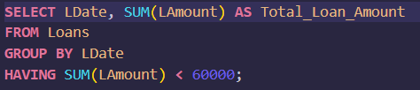Display Datewise Total of Loan where the total loan<60,000

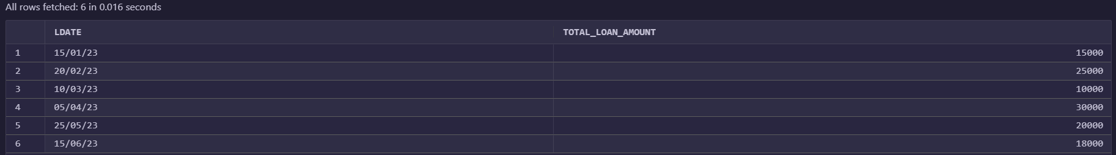

1. 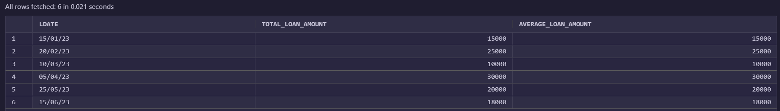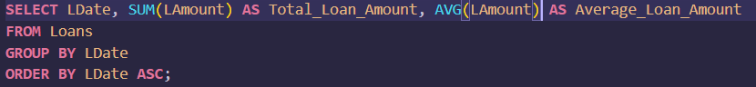Display Total Loan and average loan issued Date wise in the ascending order of date.
2. 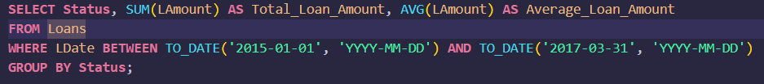Display Status and Total Loan and average loan issued Status wise for dates between 1st Jan 2015 to 31st March 2017.
3. 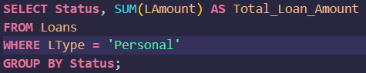Display the total loan amount Status wise (only for Personal Loan)



1. 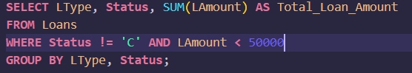Display Total loan amount based on type and status NOT ‘C’ and amount<5000



1. 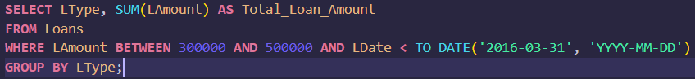Display Total loan amount based on type and for the total amount in between 3 Lacs to 5Lacs and Date <31st march 2016



1. 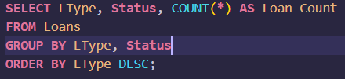Display the total count of Loans Status wise in each category in the descending order of type



**********************************************************************************

**Exercise 5:**

**Aim: Testing Aggregate functions**

**Author: 24251115**

**Date: 18/12/2024**

**********************************************************************************

1. Create the following relations
   1. 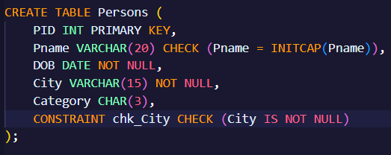Persons (PID Int Primary Key, Pname Varchar (20) in Proper case Letters, DOB Date Not Null, City Varchar (15) Not Null, Category char (3))
   2. 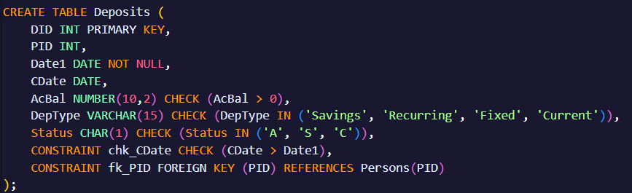Deposits (DID Int PK, PID Int FK, Date1 Date Not Null, CDate Date Cdate>Date1, AcBal Number(10,2) AcBal>0, DepType Varchar(15) accept only ‘Savings’, ‘Recurring’, ‘Fixed’, or ‘Current’ , Status Char(1) accept only ‘A’, ‘S’,’C’)

**Note : All the constraints should be added while creating the tables (name all the constraints)**

Insert 15 or more records into the above tables:

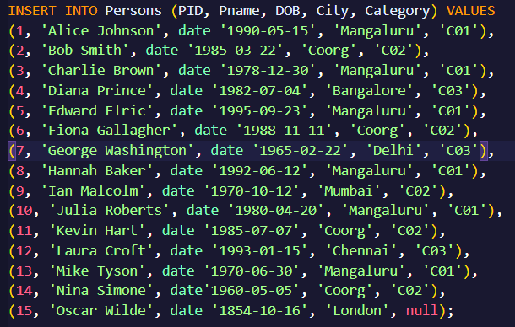



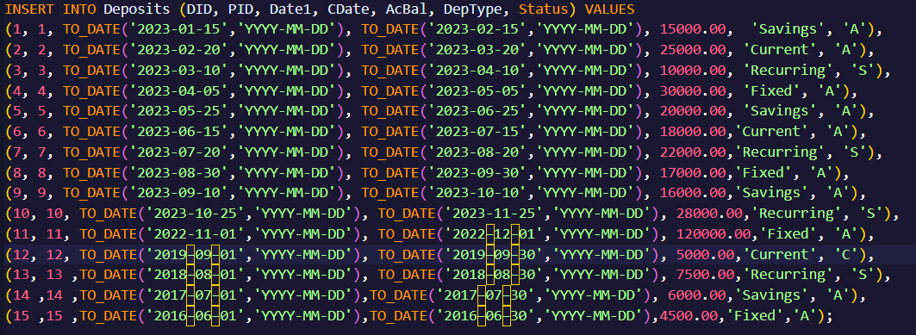



Do the following queries:

1. Count the total number of records in Persons table for city =’Mangaluru’



1. 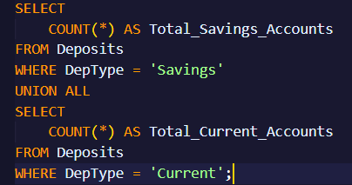Count the number of records in Deposits for savings account and Current Account



1. 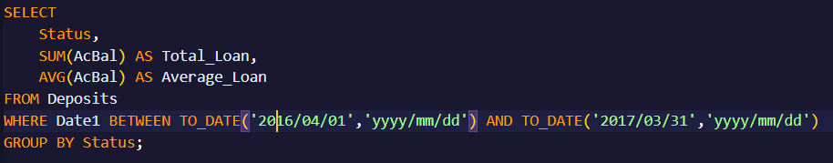Display Status and Total Loan and average loan issued Status wise for dates between 1st Apr 2016 to 31st March 2017
2. 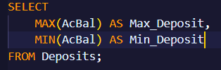Display Max and Min of Deposit amount (AcBal)



1. 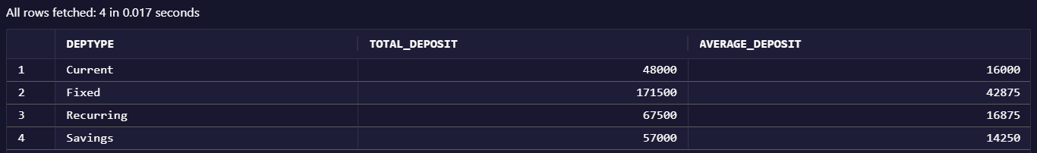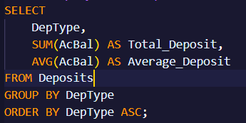Display Total Deposit and Average Deposit amount DepType-wise in the ascending order of DepType
2. 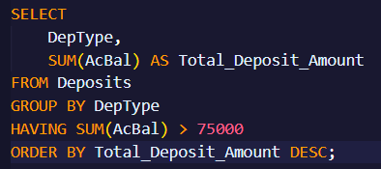Display Total Deposit amount DepType-wise for sum of amount > 75000 in the descending order TotalAmount
3. 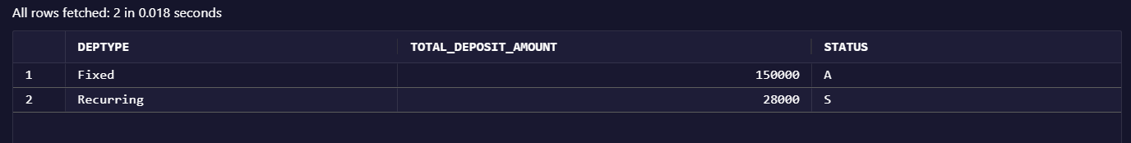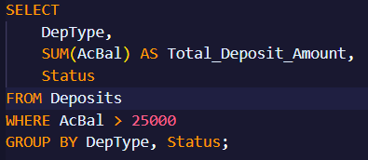Display Deposit Type, Total Deposit amount DepType and Status wise for only AcBal>25,000
4. 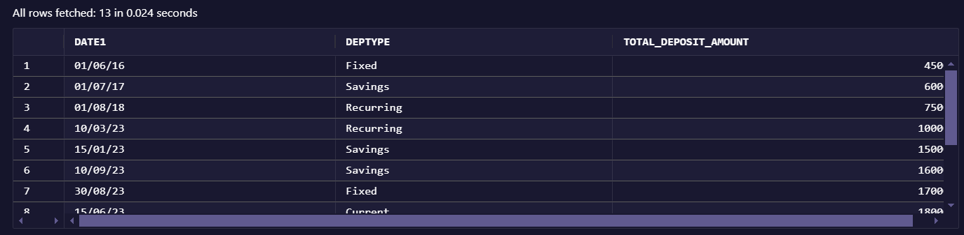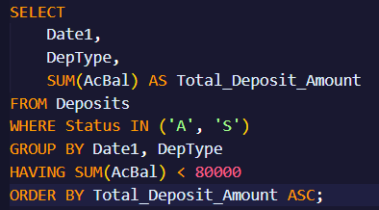Display Date1, Deposit Type, Total Deposit amount Datewise and Deposit Type wise for only Status =’A’ or ‘S’ and sum of amount <80,000 in the Ascending order of Total

**Part – II**

**Aim: i) Learning simple joins (Inner Join)**

**ii) Testing Simple joins with aggregate function**

1. 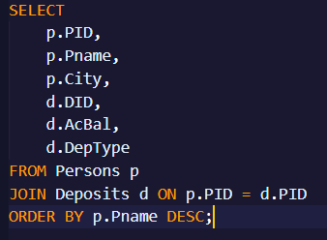Display PID, Pname, City, DID, AcBal, DepType in the descending order of Pname

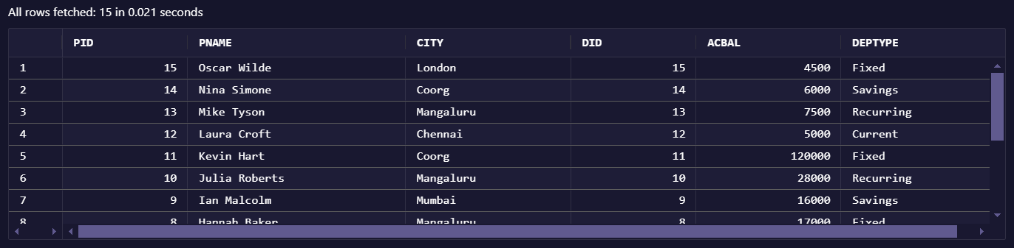

1. 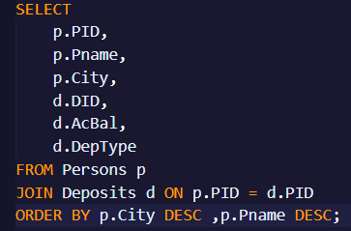Display PID, Pname, City, DID, AcBal, DepType in the descending order of city name and descending order of Pname

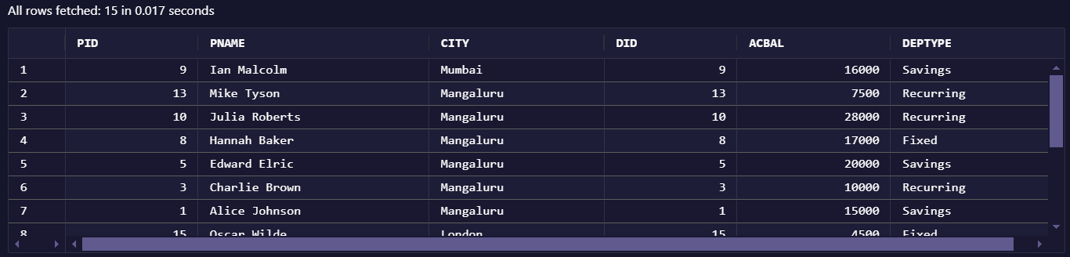

1. 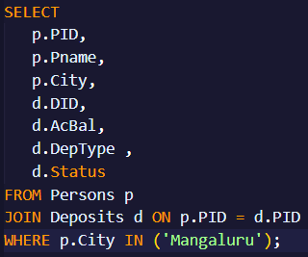Display PID, Pname, City, DID, AcBal, DepType , Status for City Name=’Mangaluru’ or ‘Coorg’

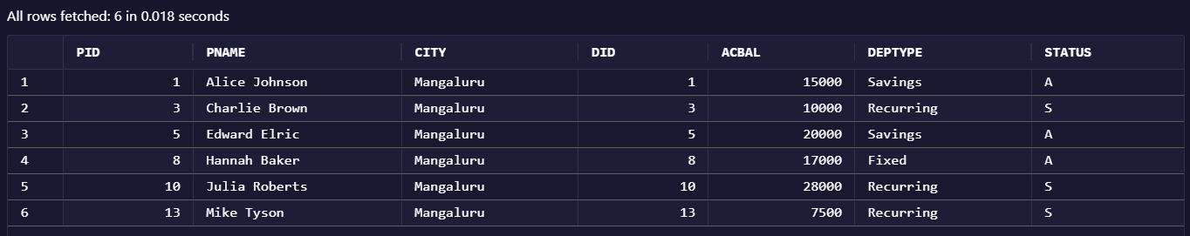

1. 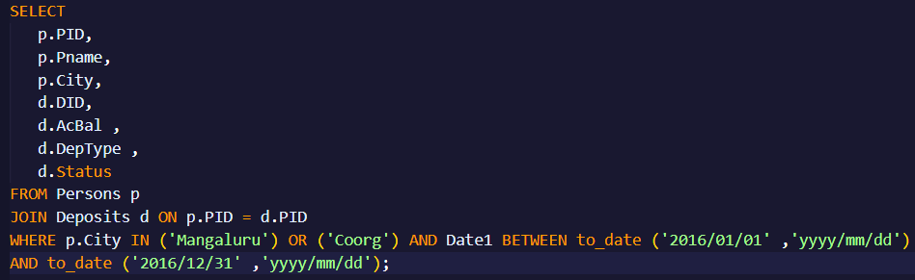Display PID, Pname, City, DID, AcBal, DepType , Status for City Name=’Mangaluru’ or ‘Coorg’ and Date1 in between 1st Jan 2016 to 31st Dec 2016



1. 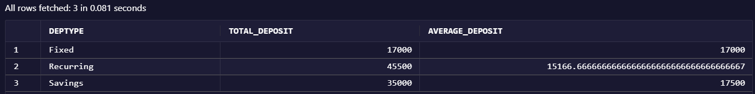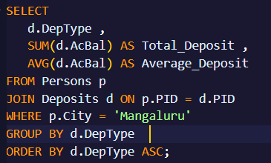Display DepType, Total Deposit and Average Deposit amount DepType-wise in the ascending order of DepType for city=’Mangaluru’
2. 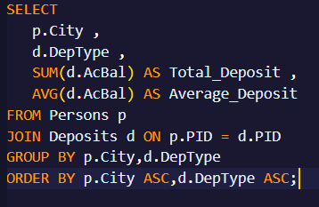Display City,Total Deposit and Average Deposit amount Citywise, DepType-wise in the ascending order of city, DepType

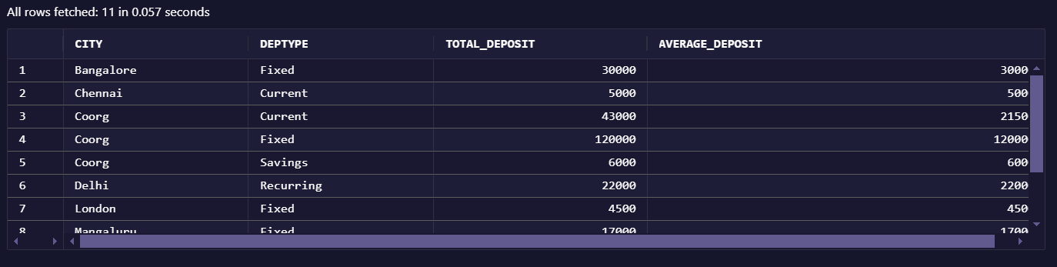

1. 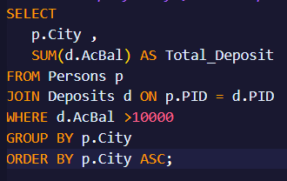Display City, Total Deposit City-wise for AcBal>10,000 in the ascending order of City

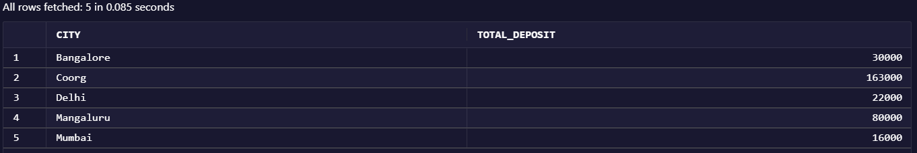

1. 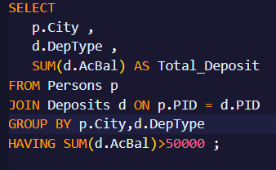Display City, DepType, Total Deposit Citywise, DepType-wise for TotalDepo amount >50,000

